Geometry and Trigonometry Basics for GAIN

This is what students need to know about geometry for the GAIN:
- Calculate perimeter of a shape: total length of all sides = perimeter. See Example 1.
- Calculate area of a square or rectangle: length x width = area (some of these are word problems). See Example 1.
- Pythagorean theorem: in a right triangle (hypotenuse c is opposite the right angle; the other 2 sides are a and b): a² + b² = c². Thus, in a triangle with sides a = 3² and b = 4², the hypotenuse c = 5² (9 + 16 +25). The formula is given in the question.
- Calculate volume of a square or rectangle: height x width x length = volume. See Example 1.
- Calculate the surface area of a square or rectangle: calculate the area of all sides and add them together. See example 3.
- Calculate the circumference of a circle: measurement of the outside of a circle: C = 2$πr$. The radius of the circle is given, ex: r = 10. They do not need to know the value of $π$ to answer the question. Answers are given as in terms of$π,$ ex: 54$π.$ The formula is given in the question. See Example 4.
- Calculate the volume of a cylinder: Volume =$π$ x radius squared x height (V =$π$r²h) These answers are given in terms of $π$ as well. The formula is given in the question. See Example 5.
- Angles that intersect parallel lines. The questions give the number of degrees for an angle on 1 line and want to know the number of degrees in a related angle on the 2nd line. Students need to remember that the total # of degrees along a line = 180. So, if they are told that angle A = 63°, it’s supplementary angle B = 117° (63 + 117 = 180). Therefore, the corresponding angle on the parallel line = 117° also. See Example 6.
- Students need to know that a right triangle is identified by a square corner where 2 lines meet. See Example 7.
- Students need to know that the total number of degrees in a triangle = 180. See Example 8.

Example 1
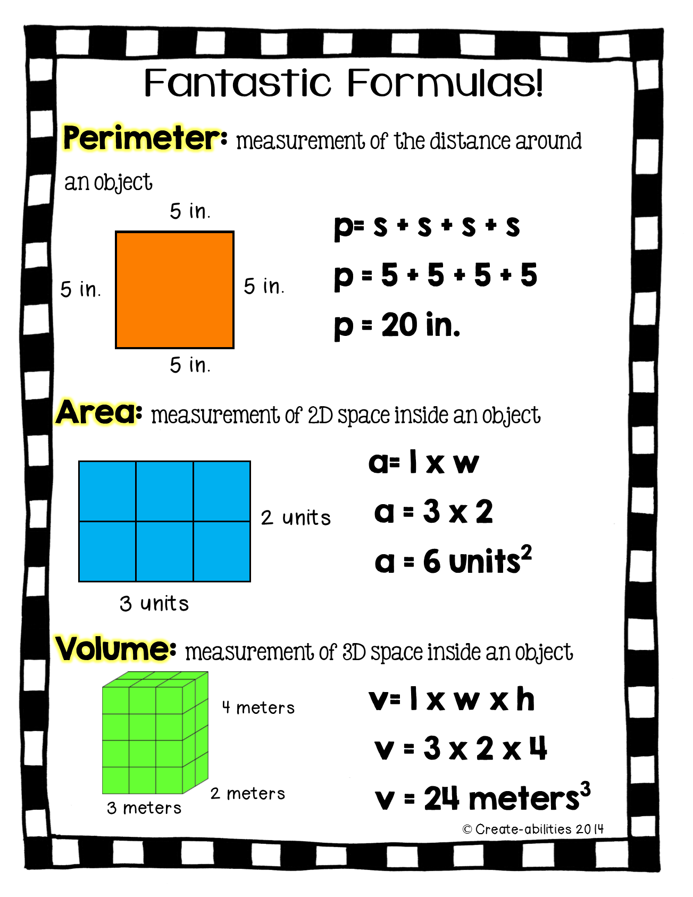

Example 2 – Pythagorean Theorem
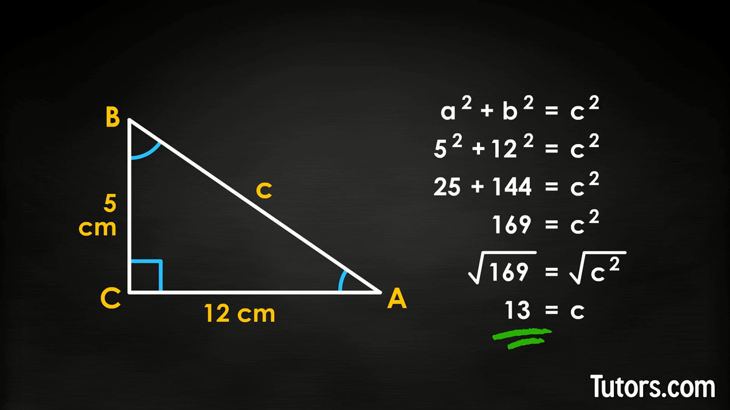

Example 3
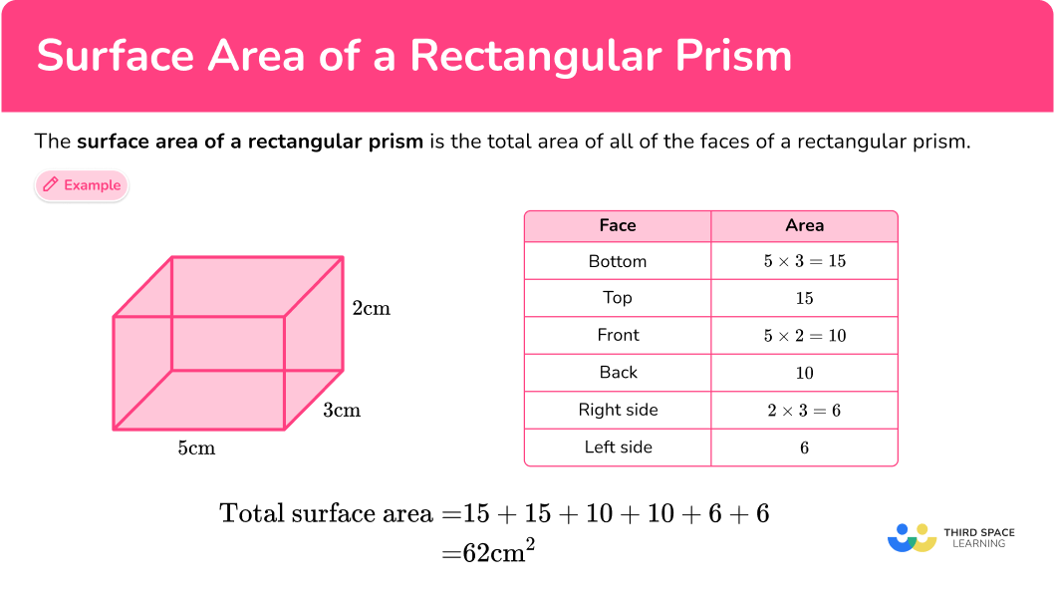

Example 4
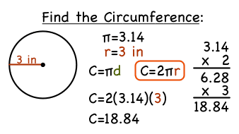

Example 5
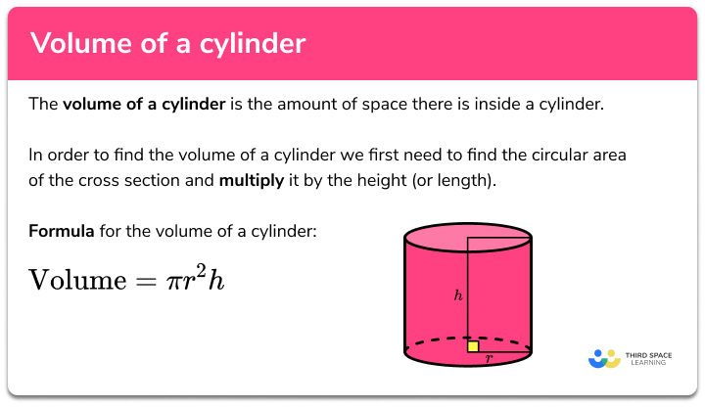

Example 6 - Angles on Parallel Lines
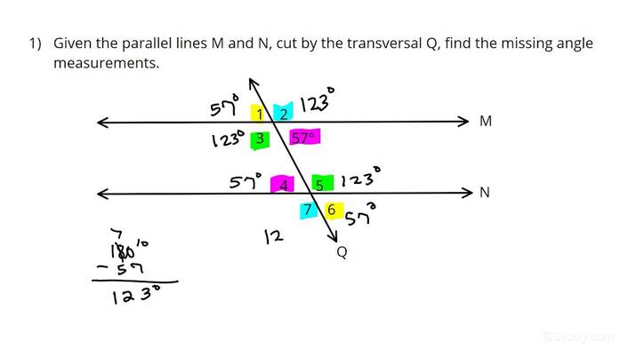
Example 7 – Right Triangles
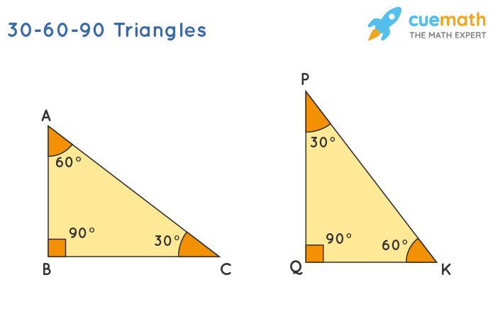

Example 8 – Total Degrees in a Triangle
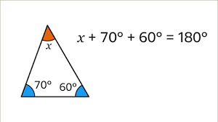
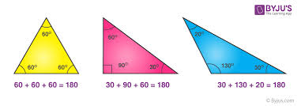

For the 1 trigonometry question on each test:
- The question includes a tangent (tan); the formula is given as tan Ɵ = $\frac{opp}{adj}$ . So the tangent of angle Ɵ is equal to the length of the opposite side divided by the length of the adjacent side. One of the variables will be given. The formula is given in the question. Students need to remember that triangles have a total of 180°, and they need to remember the Pythagorean theorem (a² + b² = c²) to calculate the length of the side in question.

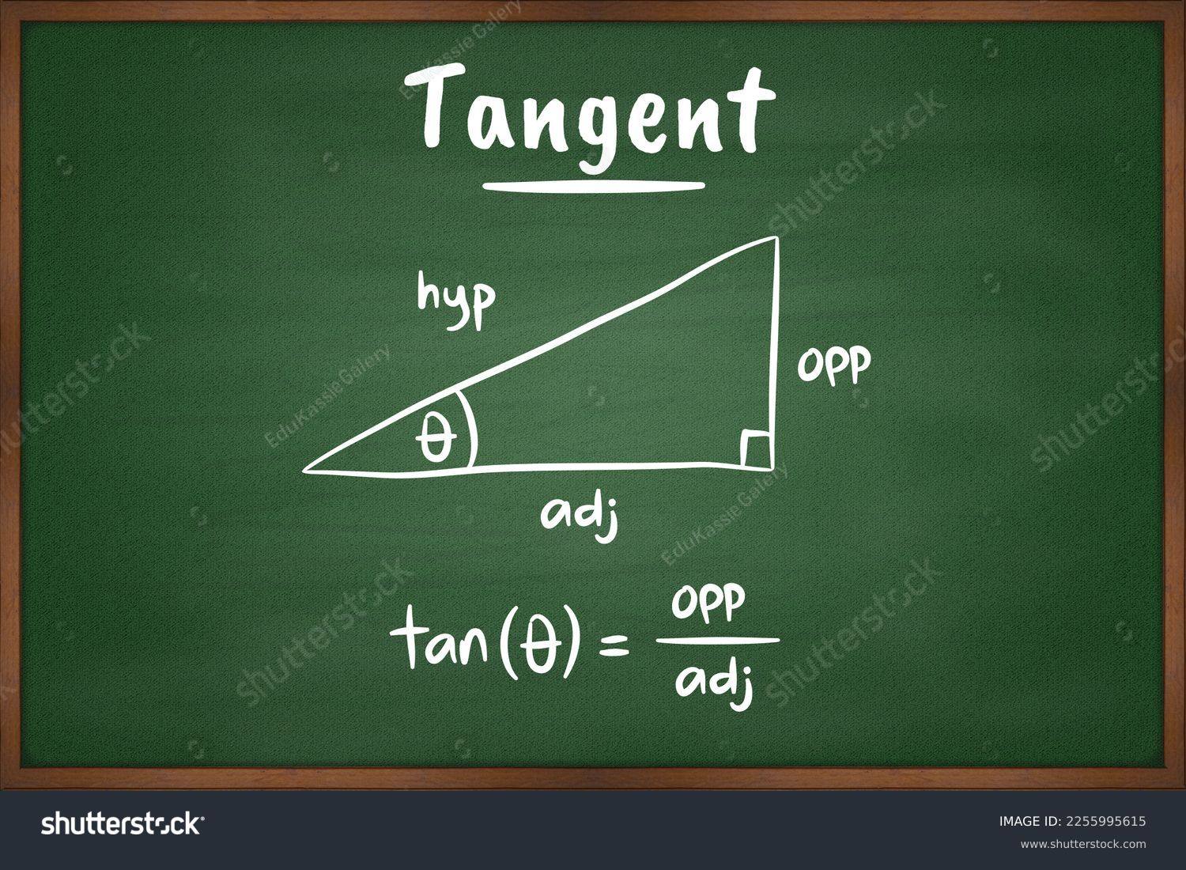

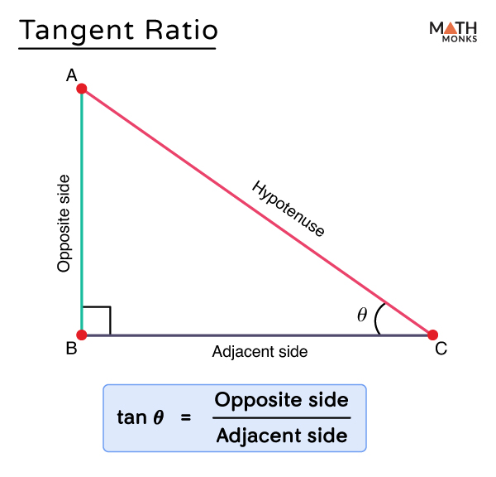
In the practice materials available for trig, only solve for tangent.

Geometry Videos
Perimeter - https://www.youtube.com/watch?v=AAY1bsazcgM&list=PLUPEBWbAHUsyDKTIYm4a_hUTgJqwI9q5C

Area - https://www.youtube.com/watch?v=xCdxURXMdFY&list=PLUPEBWbAHUsyDKTIYm4a_hUTgJqwI9q5C&index=2

Volume - https://www.youtube.com/watch?v=qJwecTgce6c&list=PLUPEBWbAHUsyDKTIYm4a_hUTgJqwI9q5C&index=5

Circles – What is Pi (π)? - https://www.youtube.com/watch?v=cC0fZ_lkFpQ&list=PLUPEBWbAHUsyDKTIYm4a_hUTgJqwI9q5C&index=3

Circles – Circumference, Area
https://www.youtube.com/watch?v=O-cawByg2aA&list=PLUPEBWbAHUsyDKTIYm4a_hUTgJqwI9q5C&index=4

Pythagorean Theorem –
https://www.youtube.com/watch?v=WqhlG3Vakw8&list=PLUPEBWbAHUsyDKTIYm4a_hUTgJqwI9q5C&index=6

Angles and Degrees - https://www.youtube.com/watch?v=_n3KZR1DSEo&list=PLUPEBWbAHUsxuIbsAS--B6cobarm2bty2&index=3

Triangles –
https://www.youtube.com/watch?v=mLeNaZcy-hE&list=PLUPEBWbAHUsxuIbsAS--B6cobarm2bty2&index=5

April 2, 2024

